JOB MARKET ANALYSIS
(PRDA - 04)

Submitted By:
Name: Bandaru Harika Hasini
Roll No: CA11202516329
Course: CDA
Institute Name: Datamites

CERTIFICATE
This is to certify that Ms. BANDARU HARIKA HASINI (Roll No: CA11202516329) has successfully completed the project titled "JOB MARKET ANALYSIS" as part of the Data Analytics Program. The project was undertaken under proper guidance and supervision and is submitted in partial fulfillment of the requirements of the course.
The objective of this project was to analyze job market data and derive meaningful insights related to employment opportunities, salary trends, industry demand, company hiring patterns, required skills, and educational qualifications. The project involved the extraction of data from the provided database, followed by data cleaning, preprocessing, transformation, analysis, and visualization using industry-standard tools and techniques.
The candidate successfully applied SQL for data retrieval and querying, Python libraries such as Pandas and NumPy for data manipulation and analysis, and Power BI/Tableau for creating interactive dashboards and visualizations. Various analytical techniques were employed to examine state-wise job distributions, average salary patterns, top hiring industries, leading recruiting companies, in-demand job titles, skill requirements, and the relationship between education and salary levels.
During the execution of the project, the candidate demonstrated strong analytical thinking, problem-solving abilities, and a thorough understanding of data analytics concepts. The project was completed with dedication, sincerity, and a professional approach. The findings and recommendations presented in the report are based on detailed analysis and provide valuable insights into current job market trends.
We further certify that this work is the original effort of the candidate and has not been submitted previously for any other academic or professional certification. To the best of our knowledge, the project satisfies all the requirements and standards prescribed for successful completion of the Data Analytics Program.

ACKNOWLEDGEMENT
I would like to express my sincere gratitude to all those who contributed to the successful completion of this project titled "Job Market Analysis". This project has provided me with an excellent opportunity to apply theoretical knowledge in a practical environment and gain valuable experience in the field of Data Analytics.
First and foremost, I would like to thank my faculty members, mentors, and project guides for their continuous guidance, encouragement, and support throughout the project. Their valuable suggestions, constructive feedback, and expert knowledge helped me understand various concepts related to data extraction, data cleaning, data analysis, and data visualization. Their guidance played a crucial role in the successful completion of this project.
I would also like to express my heartfelt thanks to the institute for providing the necessary resources, infrastructure, and learning environment required for carrying out this work. The training sessions, practical assignments, and project-based learning approach significantly enhanced my technical and analytical skills.
Special thanks are extended to all the individuals who directly or indirectly supported me during the project. Their motivation and encouragement helped me overcome challenges encountered during data collection, preprocessing, analysis, and dashboard development.
Through this project, I gained practical exposure to tools and technologies such as SQL, Python, Power BI/Tableau, and various data analytics techniques. The experience improved my problem-solving abilities, critical thinking skills, and understanding of real-world business scenarios. It also strengthened my confidence in handling data-driven projects and deriving meaningful insights from complex datasets.
Finally, I would like to express my gratitude to everyone who contributed to my learning journey and helped make this project a successful and enriching experience. The knowledge and experience gained from this project will be highly beneficial for my academic growth and future professional career.

ABSTRACT
The rapid growth of technology and data-driven decision-making has significantly transformed the modern job market. Organizations across various industries continuously seek skilled professionals to meet evolving business requirements and maintain a competitive advantage. Understanding employment trends, salary patterns, skill requirements, and hiring demands has become increasingly important for both job seekers and employers. This project, titled "Job Market Analysis," aims to analyze job posting data and generate meaningful insights that can support informed decision-making.
The dataset used in this project was obtained from the provided database and contained information related to job opportunities, companies, industries, salaries, skills, education requirements, and geographical locations. The data was extracted using SQL queries and further processed using Python. Various data preprocessing techniques, including data cleaning, handling missing values, removing duplicates, and standardizing records, were performed to ensure the accuracy and reliability of the analysis.
The project focuses on identifying states with the highest number of job opportunities, analyzing salary distributions across locations, determining the top industries and companies with maximum hiring activity, evaluating the most demanded job titles, and examining the relationship between education and salary levels. Additionally, the required skills for different job roles were analyzed to understand current market expectations and workforce demands.
To effectively communicate the findings, interactive dashboards and visualizations were developed using Power BI/Tableau. These visualizations provide a comprehensive overview of job market trends and enable users to explore data efficiently. The results highlight significant patterns related to employment opportunities, compensation structures, industry growth, and skill demand.
The insights derived from this project can help organizations improve recruitment strategies, workforce planning, and talent acquisition processes. Similarly, job seekers can utilize the findings to identify in-demand skills, promising career paths, and regions with strong employment prospects. Overall, this project demonstrates the practical application of data analytics techniques in solving real-world business problems and transforming raw data into actionable insights.

INTRODUCTION
In today's rapidly evolving business environment, data has become one of the most valuable assets for organizations. Companies increasingly rely on data-driven strategies to improve decision-making, optimize operations, and gain a competitive advantage. As a result, the demand for skilled professionals in areas such as data analysis, data science, business intelligence, and machine learning has grown significantly. Understanding job market trends has become essential for both employers seeking qualified talent and job seekers planning their careers.
This project, titled "Job Market Analysis," focuses on examining job posting data to gain a deeper understanding of current employment opportunities and workforce requirements. The analysis covers multiple aspects of the job market, including state-wise job distribution, salary trends, industry demand, company hiring activity, popular job titles, required skills, and the relationship between education and compensation. By studying these factors, meaningful insights can be derived regarding hiring patterns and labor market dynamics.
The project utilizes data obtained from the provided database and applies various data analytics techniques to transform raw information into actionable insights. The collected data is cleaned, processed, and analyzed using Python and SQL, while interactive dashboards and visualizations are developed using Power BI/Tableau. These visualizations enable users to explore the data effectively and understand complex relationships among different variables.
The findings of this project can benefit multiple stakeholders. Organizations can use the insights to improve recruitment strategies, workforce planning, and talent acquisition processes. Educational institutions can better understand industry requirements and align their programs accordingly. Job seekers can identify high-demand skills, promising career paths, and locations that offer strong employment opportunities and competitive salaries.
Overall, this project demonstrates the practical application of data analytics in understanding labor market trends and supporting informed decision-making. By converting large volumes of job-related data into meaningful information, the project highlights how analytical techniques can be used to solve real-world business problems and create value for both organizations and individuals.

OBJECTIVES
The primary objective of this project is to perform a comprehensive analysis of job market data and derive meaningful insights that can support both job seekers and organizations in making informed decisions. By analyzing various aspects of job postings, salaries, industries, companies, skills, and educational requirements, the project aims to identify important trends and patterns within the employment market. The analysis helps in understanding workforce demand, compensation structures, and the factors influencing recruitment activities. Interactive dashboards and visualizations are also developed to present the findings in a clear and user-friendly manner.
Specific Objectives
• To identify the states with the highest number of job opportunities and analyze regional employment trends.
• To compare average minimum, maximum, and overall salary levels across different states.
• To determine the top industries generating the highest number of data science and analytics-related job postings.
• To identify companies with the maximum number of job openings and evaluate their hiring activity.
• To analyze the most in-demand job titles and understand current workforce requirements.
• To compare salary levels among popular job roles and identify high-paying positions.
• To examine the skills most frequently requested by employers for different job titles.
• To study the relationship between educational qualifications and salary levels.
• To develop interactive dashboards using Power BI/Tableau for effective data visualization.
• To generate actionable insights and recommendations that can assist organizations in improving recruitment strategies and workforce planning.

DATASET DESCRIPTION
The dataset used in this project contains information related to job postings collected from various organizations across different industries and locations. It provides valuable details about employment opportunities, salary structures, hiring patterns, required skills, and educational qualifications. The dataset serves as the primary source for analyzing job market trends and generating meaningful insights.
The data includes important attributes such as State, Company Name, Industry, Job Title, Minimum Salary, Maximum Salary, Average Salary, Required Skills, and Education Qualification. These features help in understanding regional job distribution, salary trends, industry demand, and workforce requirements. Each attribute contributes to identifying key patterns within the job market.
The dataset contains both numerical and categorical data, making it suitable for various analytical techniques and visualizations. Before analysis, the data was reviewed and prepared to ensure accuracy and consistency. The information obtained from this dataset forms the foundation for all dashboards, visualizations, and insights presented in this project.
Key Attributes in the Dataset
- State: Represents the geographical location of the job posting.
- Company Name: Indicates the organization offering the job opportunity.
- Industry: Specifies the sector or business domain of the company.
- Job Title: Represents the position being offered.
- Minimum Salary: The lowest salary offered for the position.
- Maximum Salary: The highest salary offered for the position.
- Average Salary: The average compensation associated with the role.
- Required Skills: Technical and professional skills expected by employers.
- Education Qualification: Academic requirements for the job position.

DATA COLLECTION AND PREPROCESSING
The dataset used for this project was obtained from the provided database using SQL queries. The required data was extracted efficiently and imported into Python for further processing and analysis. Data collection is one of the most important stages of any analytics project, as the quality of insights depends heavily on the accuracy and completeness of the collected data.
After retrieving the data, several preprocessing techniques were applied to improve data quality and prepare it for analysis. Missing values were identified and handled appropriately, duplicate records were removed, and inconsistent entries were corrected to maintain uniformity across the dataset. Text fields such as company names, industries, and job titles were standardized to ensure consistency and avoid duplication during analysis.
Salary-related attributes were carefully reviewed, validated, and converted into appropriate numerical formats to support accurate calculations and comparisons. Data types were verified and corrected wherever necessary to ensure compatibility with analytical and visualization tools. These preprocessing steps helped eliminate errors, improve data reliability, and enhance the overall quality of the dataset.
A clean and well-structured dataset is essential for generating accurate insights and meaningful visualizations. The preprocessing activities performed in this project ensured that the data was ready for detailed analysis, dashboard development, and decision-making. Proper data preparation significantly contributed to the success and reliability of the overall project.
Another important aspect of the preprocessing phase was ensuring that the dataset was suitable for visualization and reporting purposes. The cleaned data was organized into a structured format, making it easier to perform calculations, create charts, and develop dashboards. Proper organization of the data helped improve analysis efficiency and ensured that meaningful relationships between different variables could be identified accurately.
The data collection and preprocessing stages formed the foundation of the entire project. Any inaccuracies or inconsistencies at these stages could significantly affect the final results and insights. Therefore, careful attention was given to every step of the preparation process to maintain data quality and reliability. The resulting dataset provided a strong basis for conducting detailed job market analysis and deriving actionable business recommendations.

STATES WITH MOST NUMBER OF JOBS
Objective
The objective of this analysis is to identify the states that offer the highest number of job opportunities and understand regional employment trends. Analyzing job distribution across states helps in determining areas with strong hiring demand and economic activity. This information is useful for both organizations and job seekers when making strategic decisions. The analysis also highlights regions with greater workforce requirements and employment growth. Understanding these trends provides valuable insights into the overall job market. Furthermore, it helps identify employment hubs that attract a large number of companies and skilled professionals.
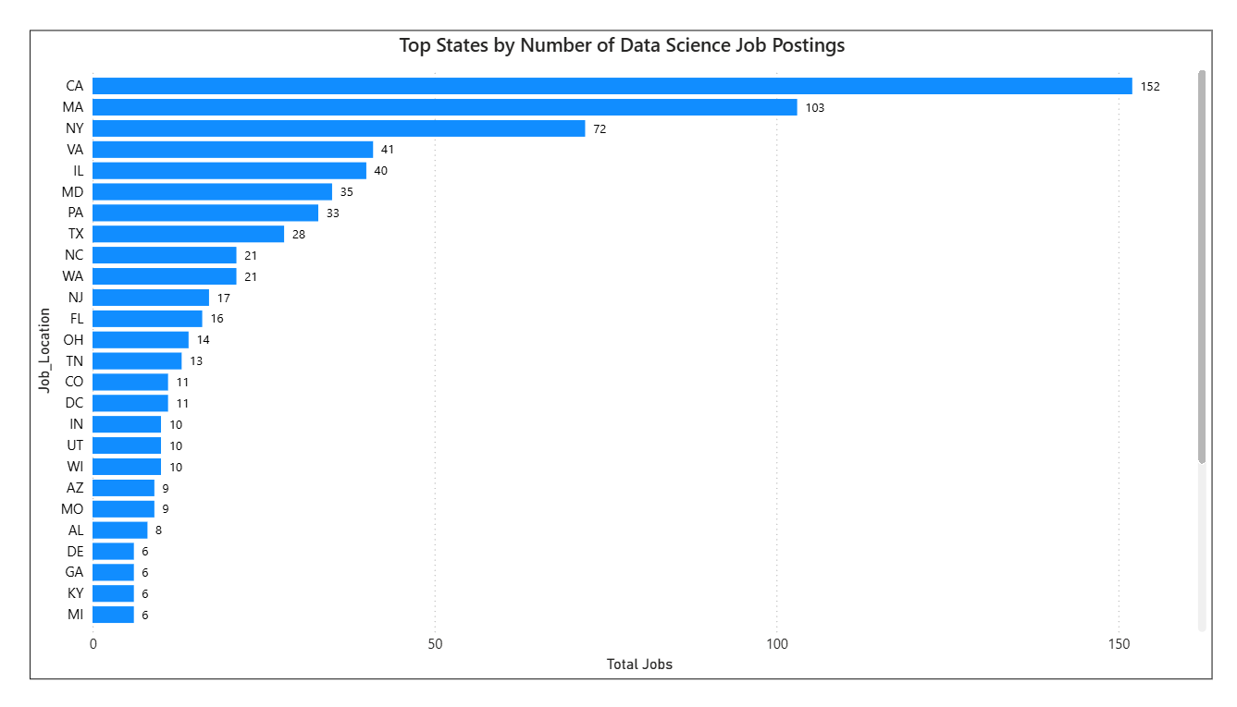
Fig: Top States by Number of Data Science Job Postings

Analysis
Job postings were grouped according to their respective states, and the total number of jobs was calculated for each location. A bar chart was created to compare the number of job opportunities across different states. The visualization makes it easier to identify states with the highest recruitment activity and employment demand. Significant differences were observed in the distribution of job postings among states. These variations indicate the impact of factors such as industry presence, business growth, and infrastructure development on hiring activity. The chart also helps in understanding how employment opportunities are concentrated in certain regions compared to others.
Insight
The analysis reveals that a few states account for a substantial portion of the total job opportunities available in the dataset. These states generally have stronger economic development, advanced infrastructure, and a larger presence of technology and business organizations. The concentration of job openings in these regions suggests a higher demand for skilled professionals. States with growing industries tend to attract more companies and create additional employment opportunities. The results demonstrate the importance of location in determining career prospects and workforce demand. Such states often serve as major employment centers and contribute significantly to overall economic growth.
Chart Observation
The chart clearly demonstrates differences in hiring demand across various states. Some states show significantly higher numbers of job postings, indicating stronger employment opportunities and active recruitment activity. These regions often have well-developed industries, better infrastructure, and a higher concentration of businesses, making them attractive locations for both employers and job seekers.
The visualization also highlights that job opportunities are not evenly distributed across all states. While certain regions experience high hiring demand, others have comparatively fewer openings. These variations may be influenced by economic growth, industry presence, workforce availability, and business expansion, emphasizing the importance of location in shaping employment trends.

AVERAGE MINIMUM AND MAXIMUM SALARY BY STATE
Objective
The objective of this analysis is to compare the average minimum and maximum salaries offered across different states. Understanding salary variations helps identify regions that provide better compensation and employment benefits. The analysis also highlights the impact of factors such as industry presence, demand for skilled professionals, and local economic conditions on salary levels. These insights can assist both organizations and job seekers in making informed decisions regarding hiring and career opportunities. Additionally, the study helps evaluate how salary structures differ across locations and provides a better understanding of regional compensation trends within the job market.
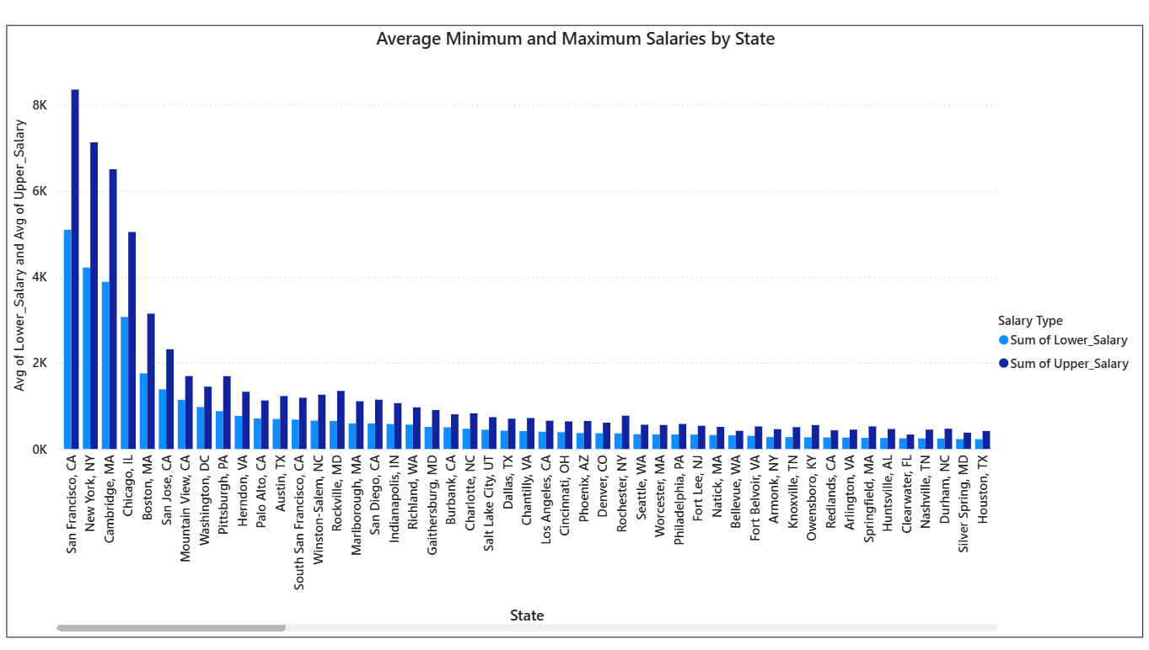
Fig: Average Minimum and Maximum Salaries by State

Analysis
Average minimum and maximum salary values were calculated for each state and visualized using a clustered bar chart. The chart enables a direct comparison between lower salary limits and upper salary limits across different locations. By examining the salary ranges, it becomes possible to identify states offering the most competitive compensation packages. The visualization also helps in understanding salary distribution patterns and regional differences in employee remuneration. Furthermore, it provides a clear overview of salary disparities and assists in identifying locations with stronger earning potential.
Insight
The analysis reveals significant variations in salary offerings across states. Certain locations provide substantially higher salary ranges, indicating strong demand for skilled professionals and a competitive job market. States with developed technology sectors, large business ecosystems, and higher living costs generally offer better compensation. The findings suggest that geographical location plays an important role in determining earning potential and career growth opportunities. Higher salary ranges may also reflect increased competition among employers to attract and retain qualified talent.
Chart Observation
The chart shows that San Francisco, CA offers the highest average salary range, followed by locations such as New York, NY, Cambridge, MA, and Boston, MA. A noticeable gap exists between minimum and maximum salaries in these regions, indicating greater earning potential and wider compensation ranges. Most other states and cities display comparatively lower salary values, suggesting differences in industry concentration and labor market demand. The visualization clearly highlights the dominance of major technology and business hubs in offering higher compensation packages. It also demonstrates that salary levels tend to decrease gradually across smaller cities and regions with lower concentrations of high-paying industries.

AVERAGE SALARY IN DIFFERENT STATES
Objective
The objective of this analysis is to determine the average salary levels offered across different states and compare compensation patterns among various locations. Understanding average salary trends helps identify regions that provide better earning opportunities for professionals. The analysis also highlights the influence of economic development, industry concentration, and workforce demand on salary structures. These insights can support both career planning and organizational decision-making. Additionally, the study helps evaluate the overall attractiveness of different states from a compensation perspective.
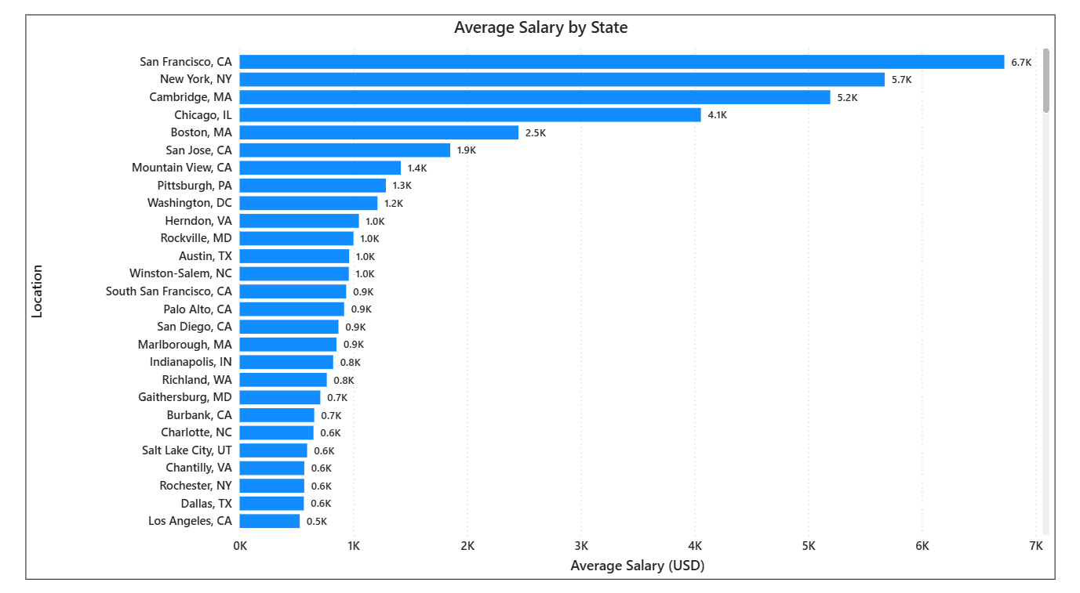
Fig: Average Salary by State

Analysis
Average salary values were calculated for each state using the available salary data and visualized through appropriate charts. The visualization provides a clear comparison of compensation levels across different locations and helps identify states offering the highest average salaries. By examining these patterns, it becomes possible to understand regional differences in earnings and workforce demand. The analysis also assists in identifying areas where organizations offer more competitive compensation packages. Such comparisons provide valuable information about salary distribution within the job market.
Insight
The analysis reveals that certain states consistently offer higher average salaries than others. These locations are typically characterized by strong economic growth, advanced industries, and increased demand for skilled professionals. States with a significant presence of technology, healthcare, finance, and business services tend to provide better compensation packages. Higher salary levels often reflect both increased living costs and greater competition for talent. The findings indicate that location is a key factor influencing earning potential and long-term career growth.
Chart Observation
The chart shows that San Francisco, CA has the highest average salary at approximately 6.7K USD, followed by New York, NY (5.7K USD) and Cambridge, MA (5.2K USD). These locations stand out significantly from the remaining states, indicating strong demand for skilled professionals and the presence of high-paying industries. Chicago, IL and Boston, MA also offer competitive average salaries, reflecting their importance as major business and employment centers.
The visualization further reveals a gradual decline in average salary levels across other locations. Cities such as San Jose, CA, Mountain View, CA, and Pittsburgh, PA provide moderate compensation, while several locations offer comparatively lower average salaries. The chart clearly demonstrates that regions with strong technology sectors, established business ecosystems, and higher living costs tend to offer better salary packages. Overall, the analysis highlights the significant influence of location on earning potential and career opportunities.

TOP 5 INDUSTRIES WITH MAXIMUM JOB POSTINGS
Objective
The objective of this analysis is to identify the industries with the highest number of job postings and understand current hiring trends across different sectors. Analyzing industry-wise recruitment activity helps determine which sectors are generating the greatest employment opportunities. The findings provide valuable insights into workforce demand, industry growth, and emerging career prospects. This information can assist both organizations and job seekers in making informed decisions regarding recruitment and career planning. Additionally, the analysis helps identify industries that are experiencing rapid expansion and increased demand for skilled professionals.
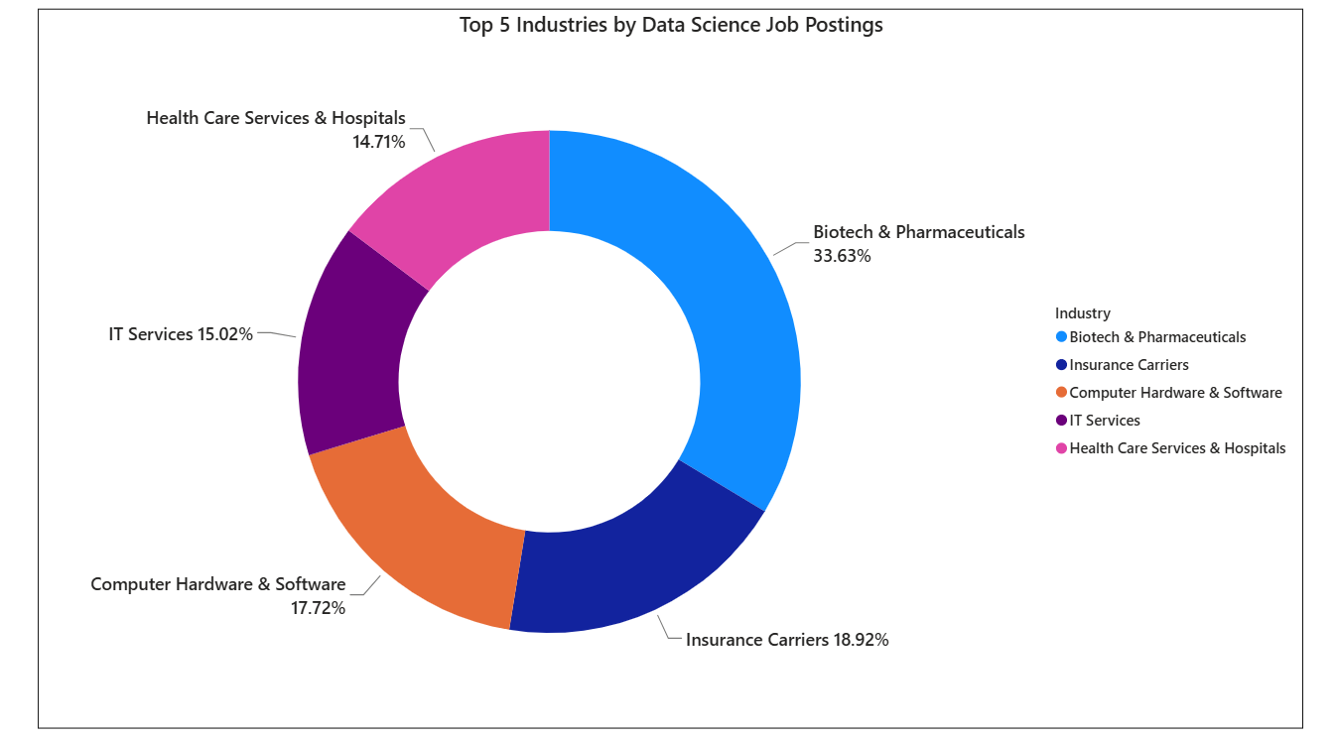
Fig: Top 5 Industries by Data Science Job Postings

Analysis
Job postings were grouped according to industry and ranked based on the total number of openings. The top five industries with the highest hiring activity were selected and visualized using a donut chart. This visualization enables a clear comparison of recruitment volumes across industries and highlights the sectors contributing most significantly to employment opportunities. The analysis helps identify industries experiencing strong growth and increased demand for skilled professionals. It also provides a better understanding of how employment opportunities are distributed across various business sectors.
Insight
The analysis reveals that industries such as biotechnology, pharmaceuticals, healthcare, information technology, and insurance account for a significant share of total job postings. These sectors continue to expand due to technological advancements, increasing business requirements, and growing demand for specialized skills. The results indicate that organizations operating within these industries are actively recruiting talent to support their business objectives. Industry growth and innovation remain key drivers of employment opportunities in the job market. The findings suggest that professionals with relevant technical and analytical skills can find promising career opportunities within these high-demand sectors.
Chart Observation
The donut chart clearly shows that Biotech & Pharmaceuticals leads all industries with approximately 33.63% of total job postings. Insurance Carriers (18.92%) and Computer Hardware & Software (17.72%) follow as the second and third largest contributors to recruitment activity. IT Services (15.02%) and Health Care Services & Hospitals (14.71%) also maintain a strong presence in the job market.
The chart indicates that healthcare and technology-related industries collectively account for a major share of employment opportunities. This distribution highlights the growing reliance on data-driven decision-making, digital transformation, and healthcare innovation across organizations. The results demonstrate that these industries continue to be major employment generators and are likely to remain important sources of job opportunities in the future.

COMPANIES WITH MAXIMUM JOB OPENINGS
Objective
The objective of this analysis is to identify organizations with the highest hiring activity and understand company-wise recruitment patterns. Analyzing the number of job openings across companies helps determine which organizations are actively expanding their workforce. The findings provide insights into employer demand, recruitment strategies, and industry growth. This information can help job seekers target companies with greater employment opportunities and support organizations in benchmarking their hiring efforts.
Additionally, the analysis helps identify companies that consistently invest in talent acquisition and workforce development. Understanding company-wise hiring trends provides valuable information about market competitiveness, business expansion, and future employment opportunities. The results can also assist stakeholders in recognizing leading employers and evaluating recruitment demand across different industries.
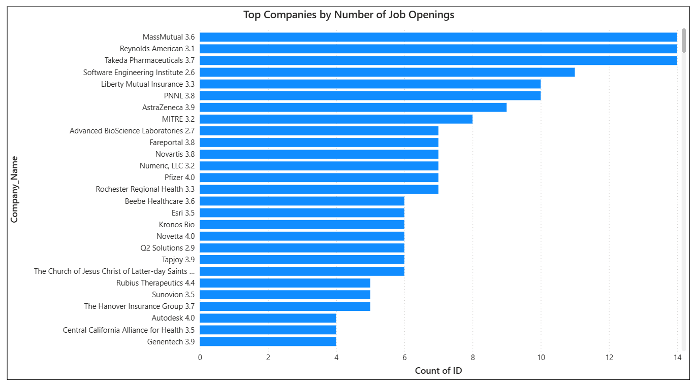
Fig: Top Companies by Number of Job Openings

Analysis
Company-wise job counts were calculated from the dataset and visualized using a horizontal bar chart. The companies were ranked according to the number of job openings to identify the leading recruiters. The visualization enables easy comparison of hiring activity among organizations and highlights companies with the strongest recruitment demand. This analysis provides a clear understanding of how job opportunities are distributed across different employers.
Insight
The analysis indicates that a relatively small number of companies account for a significant share of the total job openings. Organizations with higher recruitment activity are likely experiencing business growth, expansion projects, or increased demand for skilled professionals. These companies play an important role in generating employment opportunities and attracting qualified talent. The results suggest that hiring demand is concentrated among a few major employers within the market.
Chart Observation
The chart shows that MassMutual, Reynolds American, and Takeda Pharmaceuticals have the highest number of job openings, each with approximately 14 vacancies. Software Engineering Institute follows closely with around 11 openings, while Liberty Mutual Insurance and PNNL each have about 10 openings. These organizations emerge as the most active recruiters in the dataset.
Several other companies, including AstraZeneca, MITRE, Novartis, Pfizer, and Rochester Regional Health, also demonstrate strong hiring activity with a considerable number of job postings. The chart highlights that recruitment demand is concentrated among a group of leading organizations, particularly in the pharmaceutical, healthcare, insurance, and technology sectors. This reflects the growing need for skilled professionals in these industries.

JOB TITLES WITH MOST NUMBER OF JOBS
Objective
The objective of this analysis is to identify the job titles with the highest number of openings and understand current workforce demand. By examining the frequency of job postings, it becomes possible to determine the roles most sought after by employers. This analysis helps highlight career opportunities that are experiencing strong market demand and assists job seekers in focusing on relevant skill development. The findings also provide valuable insights into recruitment trends and talent requirements across industries.
Furthermore, the analysis helps organizations understand the availability of talent for different job roles and supports effective workforce planning. Identifying high-demand positions enables stakeholders to recognize emerging career trends and changing business requirements. The results also provide a clearer understanding of the skills and expertise that are currently valued in the job market, helping both employers and professionals make informed decisions.
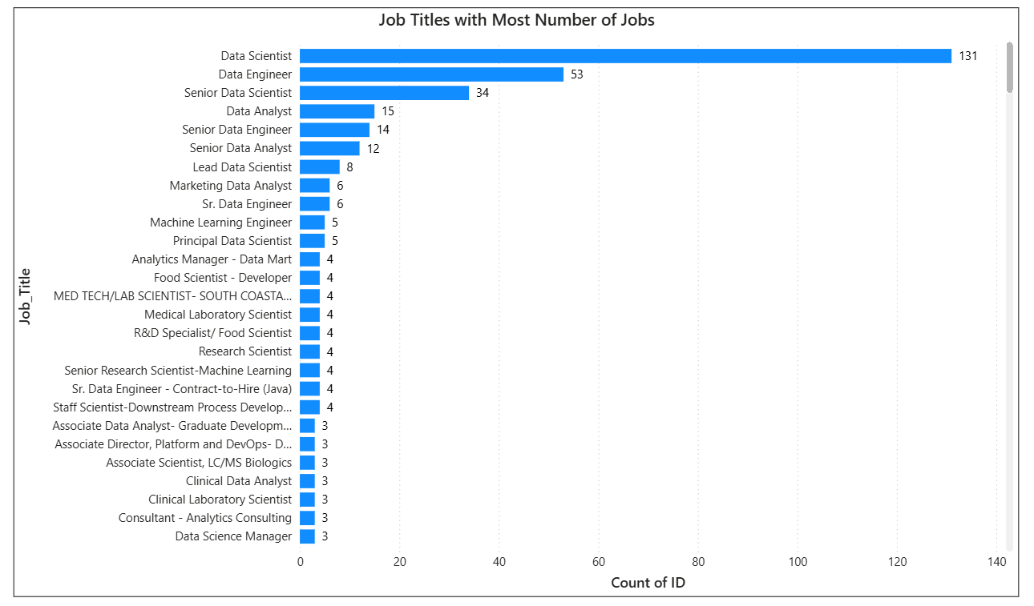
Fig: Job Titles with Most Number of Jobs

Analysis
Job titles were grouped and ranked based on the total number of job postings available in the dataset. A horizontal bar chart was used to visualize the frequency of openings for each role and compare their demand levels. The analysis helps identify the most popular positions and reveals which job categories dominate the employment market. By examining the distribution of job postings, organizations can better understand workforce requirements and hiring priorities.
Insight
The analysis indicates that data-related roles account for a significant share of total job opportunities. Positions such as Data Scientist, Data Engineer, Data Analyst, and Senior Data Scientist appear among the most frequently advertised roles. This trend reflects the increasing importance of data-driven decision-making across organizations. The findings suggest that professionals with analytical, technical, and problem-solving skills are highly valued in today's job market.
Chart Observation
The chart clearly shows that Data Scientist is the most demanded job title, with a significantly higher number of openings compared to other roles. Data Engineer ranks second, followed by Senior Data Scientist, Data Analyst, and Senior Data Engineer. The large gap between the top two roles and the remaining positions indicates exceptionally strong demand for data science and engineering professionals.
The visualization also reveals that several specialized positions, including Machine Learning Engineer, Principal Data Scientist, Research Scientist, and Data Science Manager, contribute to the overall demand for data-related talent. This pattern demonstrates that organizations are actively investing in advanced analytics, artificial intelligence, and data-driven technologies. The chart highlights the growing importance of data professionals across various industries and business functions.

SALARY OF JOB TITLES WITH MOST NUMBER OF JOBS
Objective
The objective of this analysis is to compare salary levels among the most frequently advertised job titles and understand compensation patterns across different roles. By examining average salaries, it becomes possible to identify positions that offer higher earning potential and greater financial rewards. This analysis helps job seekers evaluate career opportunities and supports organizations in developing competitive compensation strategies. The findings also provide insights into how experience, specialization, and job responsibilities influence salary levels. Understanding these trends is important for effective career planning and workforce management.
In addition, the analysis helps identify the market value associated with different job roles and highlights positions that command premium salaries. Comparing compensation across job titles enables a better understanding of employer expectations and industry standards.
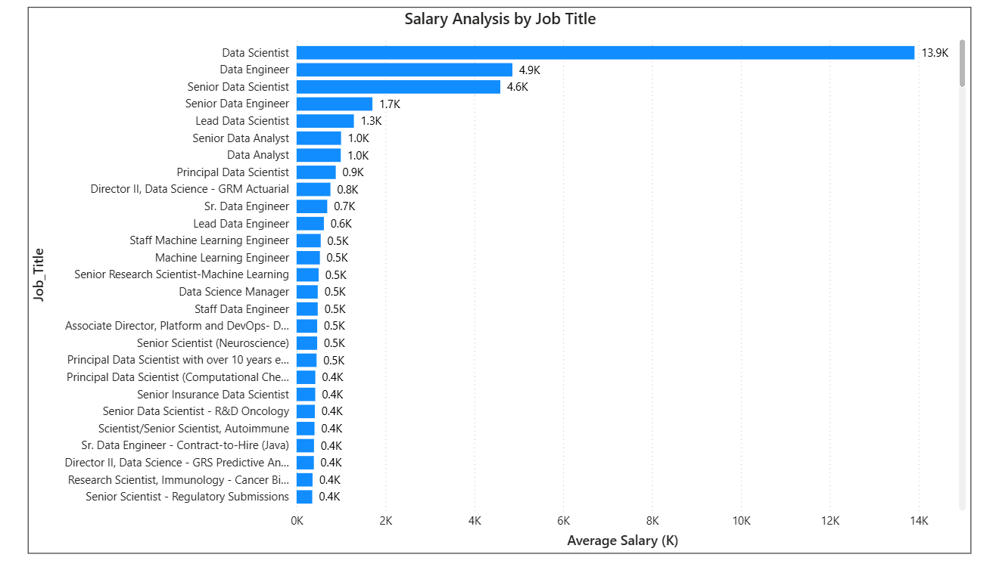
Fig: Salary Analysis by Job Title

Analysis
Average salary values were calculated for the most popular job titles identified in the dataset. The salaries were compared using visualizations to highlight differences in compensation among various roles. This approach enables a clear understanding of which positions offer higher pay and how salary levels vary across job categories. The analysis also helps identify the relationship between job demand and compensation. By comparing salary trends, valuable insights can be obtained regarding market value and employer expectations.
Insight
The analysis indicates that specialized and senior-level positions generally receive higher compensation than entry-level roles. Job titles such as Senior Data Scientist, Principal Data Scientist, Machine Learning Engineer, and Data Science Manager tend to offer more competitive salary packages due to their advanced responsibilities and expertise requirements. In contrast, entry-level and support-oriented positions typically receive comparatively lower salaries. The findings suggest that professional experience, technical expertise, and leadership responsibilities significantly influence earning potential. Continuous skill development and specialization can therefore contribute to higher career growth and compensation opportunities.
Chart Observation
The horizontal bar chart illustrates a dramatic, right-skewed distribution in average salary allocations across various data-related job titles. The role of "Data Scientist" acts as a massive statistical outlier, commanding an overwhelming lead at an average of 13.9K, which is nearly triple the compensation of the next highest role, "Data Engineer" (4.9K). Beyond these top two positions and the "Senior Data Scientist" role (4.6K), compensation drops off sharply into a steep plateau.
While standard analyst roles sit moderately at 1.0K, the vast majority of specialized, hyper-specific research and managerial titles—particularly those tied to niche scientific fields like oncology, immunology, and neuroscience—cluster tightly at the bottom of the chart, maintaining a flat and uniform distribution between 0.4K and 0.5K. This visual trend highlights that generalist, high-level data execution and engineering roles hold an immense premium in this dataset compared to granular, domain-specific scientific specializations.

SKILLS REQUIRED BY COMPANIES
Objective
The objective of this analysis is to identify the key skills most frequently required by companies across different job roles. Understanding skill requirements helps determine the competencies that employers consider essential for successful job performance. This analysis enables job seekers to focus on developing relevant technical and professional skills that align with industry expectations. It also helps organizations understand current workforce capabilities and recruitment requirements. By examining skill demand, valuable insights can be gained into evolving industry trends and emerging technologies.
Furthermore, the analysis helps identify the skills that are common across multiple job roles as well as those that are specific to specialized positions. Understanding these requirements allows professionals to enhance their employability and remain competitive in the job market. The findings can also support educational institutions and training providers in designing programs that match industry needs.
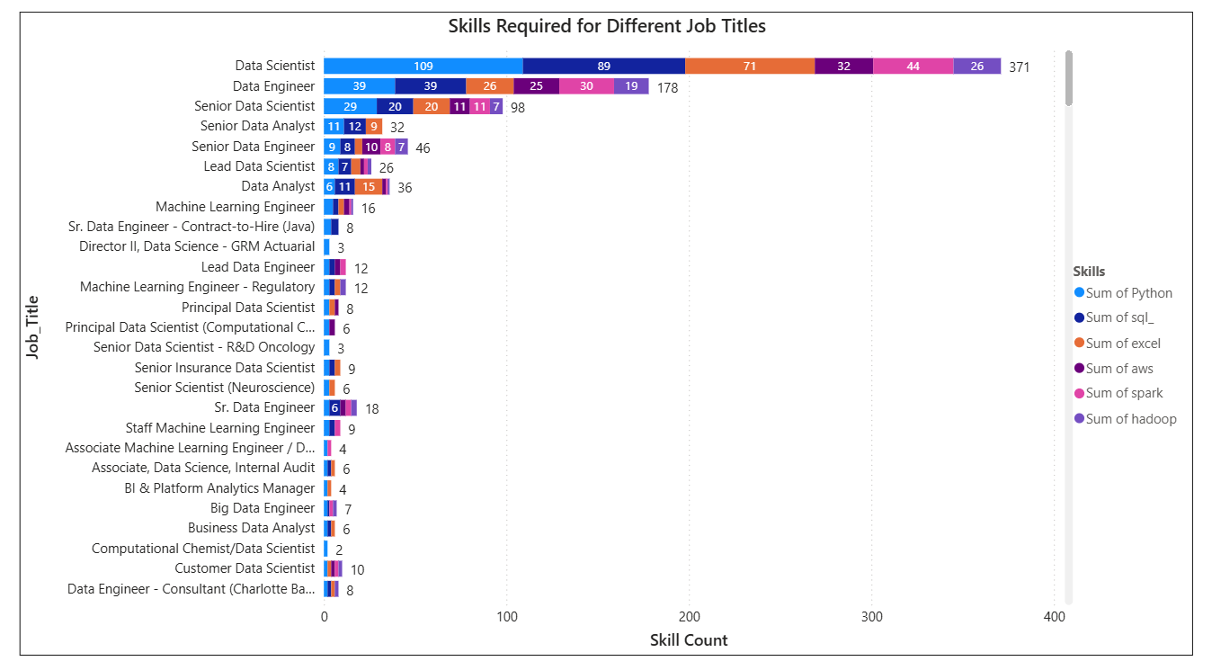
Fig: Skills Required for Different Job Titles

Analysis
Skills were extracted from job descriptions and analyzed for each job title. The frequency of skill occurrences was calculated to identify the most commonly requested competencies across different roles. The analysis helps determine which technical and analytical skills are highly valued by employers and how skill requirements vary among positions.
Insight
The results indicate that Python, SQL, Tableau, Power BI, Machine Learning, Statistics, Data Analysis, and Data Visualization are among the most frequently requested skills. These competencies form the foundation of many data-related roles and are widely used for data processing, analysis, reporting, and decision-making. The findings suggest that professionals possessing these skills have greater opportunities for employment and career advancement in the current job market.
Chart Observation
The bar chart displays a clear, stepwise descending pattern in average compensation as formal academic designations shift from unspecified to advanced graduate degrees. Roles categorized under "na" (Not Applicable/Unspecified) hold a dominant market lead, commanding an average salary of 36.3K out-earning Master’s degree roles ("M" at 26.6K) by nearly 10K, and outpacing Doctorate-level roles ("P" at 12.4K) by nearly triple the amount. This highly unexpected distribution reveals a steep negative slope as academic specialization increases.
Rather than showing a traditional return on educational investment, the data demonstrates that positions explicitly requiring a Ph.D. sit at the lowest tier of this compensation scale. This visual trend strongly implies that the highest-paying roles in this specific ecosystem bypass strict, traditional degree filters entirely, favoring alternative benchmarks like highly specialized technical skills or senior industry tenure, while positions strictly bound to rigid academic credentials face a distinct salary ceiling.

RELATION BETWEEN EDUCATION AND SALARY
Objective
The objective of this analysis is to examine the relationship between educational qualifications and salary levels offered in the job market. Understanding how education influences compensation helps identify the value of academic credentials in career growth and professional development. This analysis enables organizations and job seekers to understand the impact of educational attainment on earning potential. The findings provide insights into how different qualification levels contribute to salary variations across job roles and industries.
Additionally, the study helps determine whether higher educational qualifications lead to better compensation and increased career opportunities. It also highlights the importance of continuous learning and advanced education in meeting industry requirements. By analyzing salary patterns across education levels, valuable information can be obtained regarding workforce expectations and employer preferences. These insights can support students and professionals in making informed decisions about their educational and career paths.
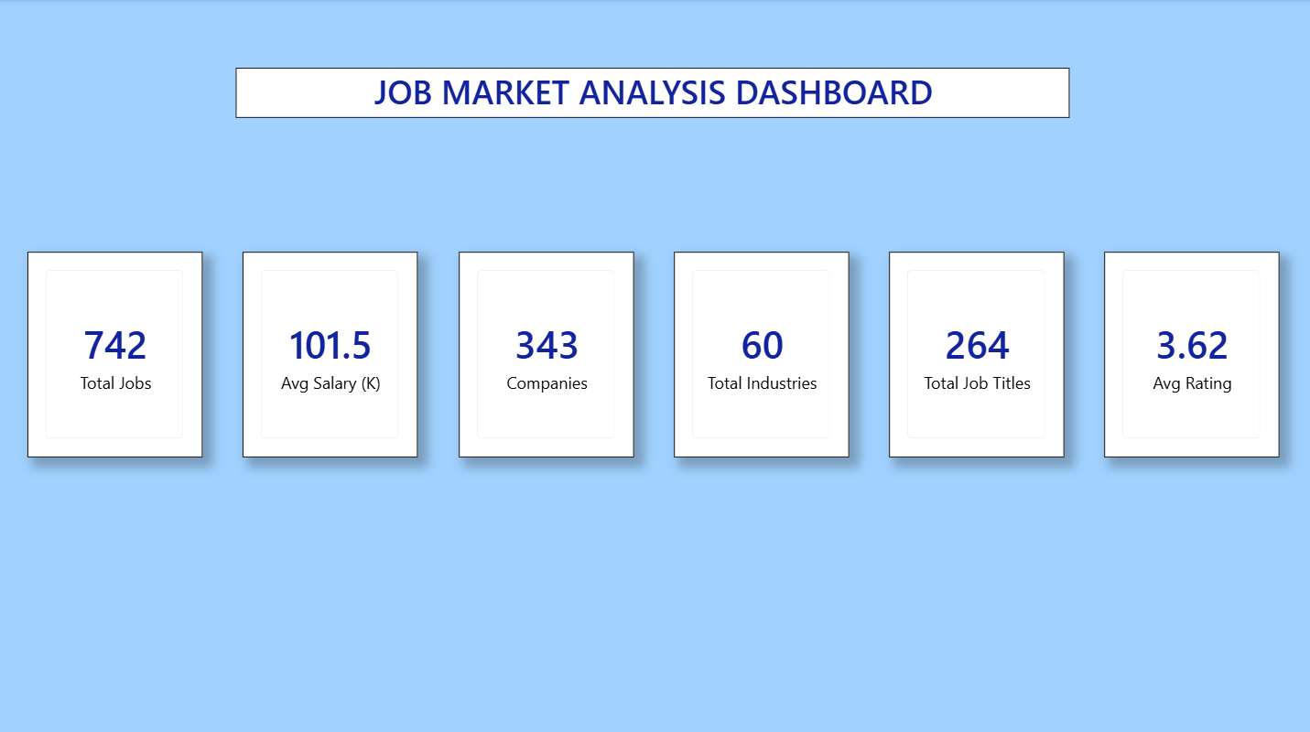
Fig: Job Market Analysis Dashboard

Analysis
Average salary values were calculated and compared across different education levels using appropriate visualizations. The analysis focuses on identifying salary differences among candidates with varying academic qualifications. By comparing compensation patterns, it becomes possible to understand the influence of education on earning potential and career advancement opportunities. The visualization provides a clear representation of how salary levels vary based on educational attainment.
Insight
The analysis indicates that higher educational qualifications generally correspond to better salary packages and increased earning potential. Professionals with advanced degrees often receive higher compensation due to their specialized knowledge, technical expertise, and ability to handle complex responsibilities. The findings suggest that education plays a significant role in career progression and remains an important factor influencing salary levels in the job market.
Chart Observation
The dashboard highlights critical aggregate market benchmarks, including a baseline of 742 Total Jobs spanning 343 Companies and 60 Total Industries, featuring 264 unique Total Job Titles with a steady 3.62 Average Rating. Crucially, the overall market dictates a baseline Average Salary of 101.5 (K). When cross-referenced with educational tiers, roles that bypass traditional education filters (the "na" category) stand massively above this market average. Meanwhile, jobs specifying a Master's degree align closer to the standard baseline, and roles strictly requiring a Doctorate drop drastically below the general industry benchmark.

DASHBOARD KPI ANALYSIS
Dashboard Overview
The dashboard was designed to provide a comprehensive view of job market trends through interactive visualizations and key performance indicators. It integrates multiple charts, filters, and summary metrics into a single interface, enabling users to explore the data efficiently. The dashboard presents information related to job opportunities, salary distributions, industry demand, company hiring activity, educational requirements, and skill trends.
Interactive filters allow users to analyze specific segments of the data and gain deeper insights into recruitment patterns. The visual representation of complex datasets simplifies data interpretation and supports effective decision-making. By combining multiple analytical perspectives into one platform, the dashboard provides a clear and user-friendly overview of the job market. Overall, it serves as a valuable tool for understanding workforce demand and employment trends.
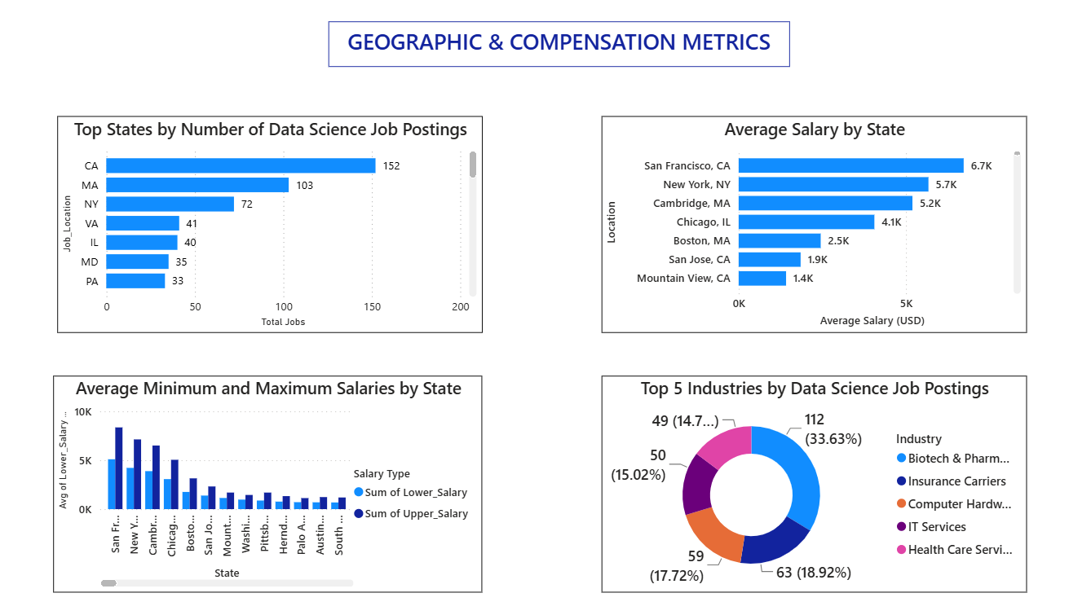

Dashboard KPI Analysis
The dashboard includes several Key Performance Indicators (KPIs) that provide a quick summary of the overall job market. Important metrics such as Total Jobs, Average Salary, Total Companies, and Total Industries help users understand the scale and characteristics of the dataset at a glance. These indicators serve as the foundation for evaluating recruitment activity and market conditions.
The KPI section enables users to monitor hiring demand, compensation levels, and industry participation efficiently. By reviewing these metrics, organizations can assess workforce requirements and compare recruitment performance. Job seekers can also use the information to understand market opportunities and salary expectations. The KPI dashboard enhances decision-making by presenting critical information in a concise and easily understandable format.
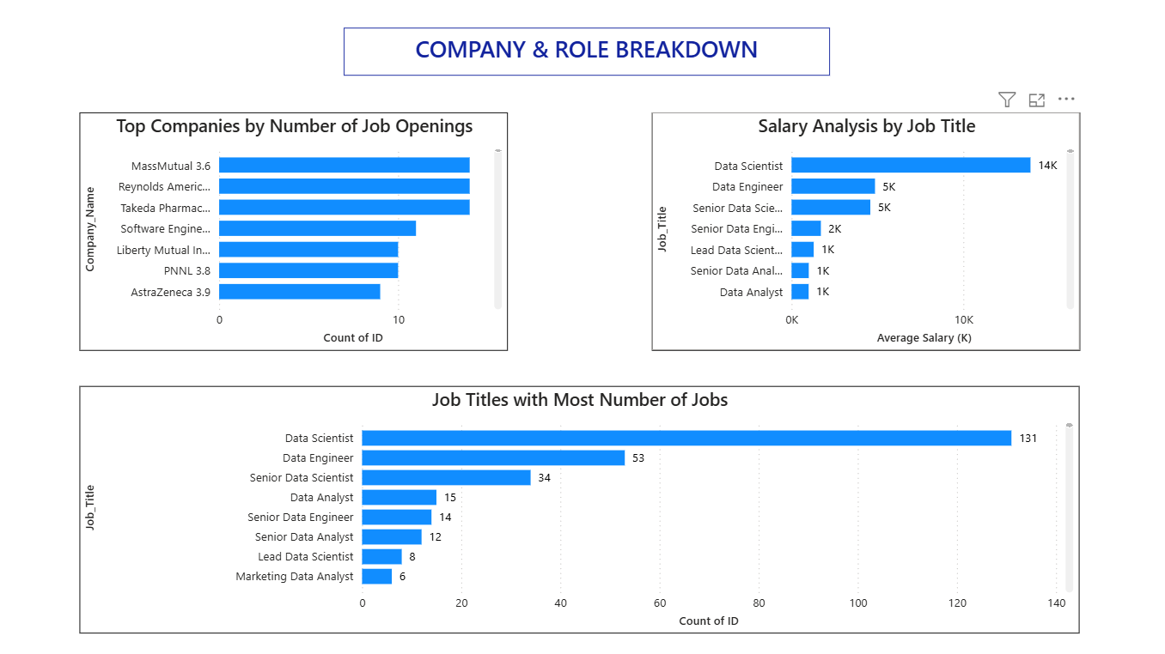

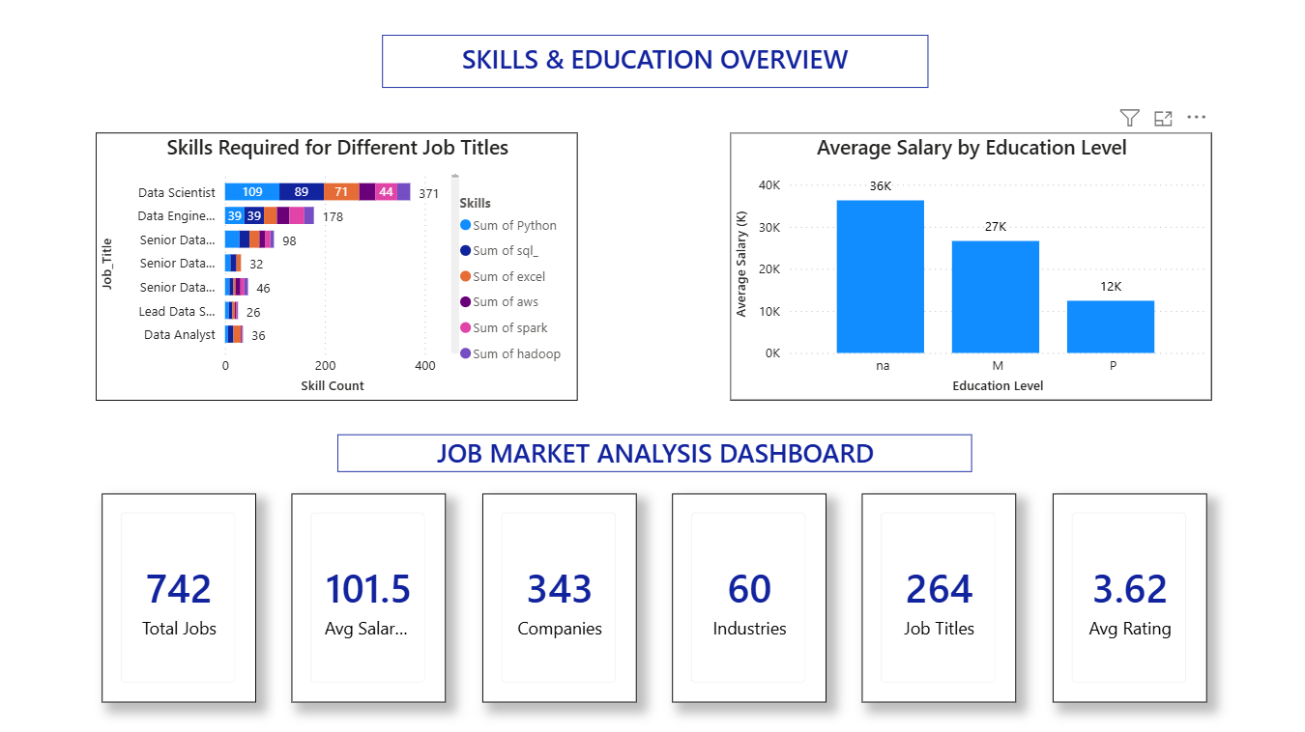

In addition, KPIs help in identifying overall trends and patterns in the job market over time. They make it easier to compare different segments such as industries, job roles, and locations, providing a clearer understanding of where demand is increasing or decreasing.
The dashboard also supports faster and more effective decision-making by converting complex datasets into simple, measurable indicators. This allows both recruiters and candidates to quickly interpret key insights without needing to analyze raw data manually.
Furthermore, the KPI dashboard enhances decision-making by presenting critical information in a concise and easily understandable format. It improves data accessibility and ensures that users can focus on the most important aspects of the job market without confusion.

BENEFITS OF THE PROJECT
This project provides valuable insights into current job market trends using data analytics techniques, helping both organizations and job seekers make informed decisions. Organizations can understand hiring patterns, salary distributions, and skill demands, which helps in designing better recruitment strategies and competitive compensation structures.
For job seekers, the project highlights the most in-demand skills, high-paying job roles, and emerging industries. This enables candidates to focus on relevant skill development and improve their employability in competitive fields like Data Science, Software Development, and Analytics.
Additionally, the analysis helps identify location-based job opportunities, allowing users to understand which regions offer better career growth and salary prospects. This supports individuals in making better relocation or remote work decisions based on data-driven insights rather than assumptions.
Furthermore, the project improves awareness of industry trends and future job market directions. By analyzing real-world data, it helps predict which skills and roles are likely to grow in demand, enabling early preparation and continuous upskilling for long-term career stability.
The project also enhances decision-making efficiency by reducing uncertainty in both hiring and job searching processes. With structured insights derived from data, stakeholders can avoid guesswork and rely on factual trends to guide their career and recruitment strategies.
In addition, it promotes transparency in the job market by clearly showing salary ranges, skill requirements, and demand levels across different roles. This helps create a more balanced understanding between employers and candidates, leading to better job matching and improved workforce satisfaction.

CONCLUSION
The Job Market Analysis project successfully examined various aspects of employment trends using data analytics techniques and visualization tools. The dataset was collected, cleaned, processed, and analyzed to identify meaningful patterns related to job opportunities, salary structures, industry demand, company hiring activity, skill requirements, and educational qualifications. The use of Power BI/Tableau dashboards enabled effective presentation and interpretation of the findings.
The analysis revealed that factors such as location, industry, job role, technical skills, and education significantly influence employment opportunities and compensation levels. Data-related positions continue to experience strong demand, while technical skills such as Python, SQL, Power BI, Tableau, and Machine Learning remain highly sought after by employers. Higher educational qualifications and specialized expertise were also found to contribute positively to salary growth.
Additionally, the study highlights that the job market is highly dynamic and continuously evolving with technological advancements. Emerging fields such as Artificial Intelligence, Data Science, and Cloud Computing are creating new job opportunities, while traditional roles are gradually transforming with automation and digital tools.
The insights generated from this analysis can support both job seekers and organizations in making informed decisions. Candidates can better plan their skill development and career paths, while companies can refine their hiring strategies to attract suitable talent in a competitive market.
Overall, this project demonstrates the effectiveness of data analytics in understanding real-world employment trends. It provides a structured and data-driven approach to interpret job market behavior and contributes to better workforce planning and career development strategies.

